The Generation of Dorsal-Ventral Polarity
In 1936, embryologist E. E. Just criticized those geneticists who sought to explain Drosophila development by looking at specific mutations affecting eye color, bristle number, and wing shape. He said that he wasn't interested in the development of the bristles of a fly's back; rather, he wanted to know how the fly embryo makes the back itself. Fifty years later, embryologists and geneticists are finally answering that question.*
The Morphogenetic Agent for Dorsal-Ventral Polarity
Dorsal-ventral polarity is established by the gradient of a transcription factor called Dorsal. Unlike Bicoid, whose gradient is established within a syncytium, Dorsal forms a gradient over a field of cells that is established as a consequence of cell-to-cell signaling events.
The specification of the dorsal-ventral axis takes place in several steps. The critical step is the translocation of the Dorsal protein from the cytoplasm into the nuclei of the ventral cells during the fourteenth division cycle. Anderson and Nüsslein-Volhard 1984 isolated 11 maternal effect genes, each of whose absence is associated with a lack of ventral structures (Figure 9.33). The absence of another maternal effect gene, cactus, causes the ventralization of all cells. The proteins encoded by these maternal genes are critical for making certain that the Dorsal protein gets into only those nuclei on the ventral surface of the embryo.† After its translocation, the Dorsal protein acts on cell nuclei to specify the different regions of the embryo. Different concentrations of Dorsal protein in the nuclei appear to specify different fates in those cells.
The Translocation of Dorsal Protein
The protein that actually distinguishes dorsum (back) from ventrum (belly) is the product of the dorsal gene. The RNA transcript of the mother's dorsal gene is placed in the oocyte by her ovarian cells. However, Dorsal protein is not synthesized from this maternal message until about 90 minutes after fertilization. When this protein is translated, it is found throughout the embryo, not just on the ventral or dorsal side. How, then, can this protein act as a morphogen if it is located everywhere in the embryo?
In 1989, the surprising answer was found (Roth et al. 1989; Rushlow et al. 1989; Steward 1989). While Dorsal protein can be found throughout the syncytial blastoderm of the early Drosophila embryo, it is translocated into nuclei only in the ventral part of the embryo (Figure 9.34A, B).In the nucleus, Dorsal binds to certain genes to activate or suppress their transcription. If Dorsal does not enter the nucleus, the genes responsible for specifying ventral cell types (snail and twist) are not transcribed, the genes responsible for specifying dorsal cell types (decapentaplegic and zerknüllt) are not repressed, and all the cells of the embryo become specified as dorsal cells.
This model of dorsal-ventral axis formation in Drosophila is supported by analyses of mutations that give rise to an entirely dorsalized or an entirely ventralized phenotype (see Figures 9.33A and 9.34). In those mutants in which all the cells are dorsalized (as is evident by their dorsal cuticle), Dorsal protein does not enter the nucleus in any cell. Conversely, in those mutants in which all cells have a ventral phenotype, Dorsal protein is found in every cell nucleus.
The signal cascade
Signal from the oocyte nucleus to the follicle cells.
If Dorsal protein is found throughout the embryo, but gets translocated into the nuclei of only ventral cells, then something else must be providing asymmetrical cues (Figure 9.35). It appears that this signal is mediated through a complex interaction between the oocyte and its surrounding follicle cells.
The follicular epithelium surrounding the developing oocyte is initially symmetrical, but this symmetry is broken by a signal from the oocyte nucleus. The oocyte nucleus is originally located at the posterior end of the oocyte, away from the nurse cells. It then moves to an anterior dorsal position and signals the overlying follicle cells to become the more columnar dorsal follicle cells (Montell et al. 1991; Schüpbach et al. 1991). The dorsalizing signal from the oocyte nucleus appears to be the product of the gurken gene (Schüpbach 1987; Forlani et al. 1993). The gurken message becomes localized in a crescent between the oocyte nucleus and the oocyte plasma membrane, and its protein product forms an anterior-posterior gradient along the dorsal surface of the oocyte (Neuman-Silberberg and Schüpbach 1993; Figure 9.36). Since it can diffuse only a short distance, the Gurken protein reaches only those follicle cells closest to the oocyte nucleus. Mutations of the Gurken gene in the mother (and thus in the oocyte) cause the ventralization of both the embryo and its surrounding follicle cells. Mutations of this gene in the mother (and thus in the oocyte) cause the ventralization of both the embryo and its surrounding follicle cells. (If the mutation is in the follicle cells and not in the egg, the embryo is normal.)
The Gurken signal is received by the follicle cells through a receptor encoded by the torpedo gene. Molecular analysis has now established that gurken encodes a homologue of the vertebrate epidermal growth factor (EGF), while torpedo encodes a homologue of the vertebrate EGF receptor (Price et al. 1989; Neuman-Silberberg and Schüpbach 1993). Maternal deficiency of torpedo causes the ventralization of the embryo. Moreover, the torpedo gene is active in the ovarian follicle cells, not in the embryo. This was discovered by making germ line/somatic chimeras. Schüpbach (1987) transplanted germ cell precursors from wild-type embryos to embryos whose mothers carried the torpedo mutation. Conversely, she transplanted the germ cells of the torpedo mutant embryos to the wild-type embryos (Figure 9.37). When mated to wild-type males, the wild-type eggs produced ventralized embryos when they developed within the torpedo mutant mothers' follicles. The torpedo mutant eggs were able to produce normal embryos if they developed within a wild-type ovary. Thus, unlike the gurken gene product, the wild-type torpedo gene is needed in the follicle cells, not in the egg itself.
Signal from the follicle cells to the oocyte cytoplasm.
The activated Torpedo receptor protein inhibits the expression of the pipe gene. As a result, the Pipe protein is made only in the ventral follicle cells (Sen et al. 1998). The Pipe protein (in some as yet unknown way) activates the Nudel protein, which is secreted to the cell membrane of the ventral embryonic cells. A few hours later in development, the activated Nudel protein initiates the activation of three serine proteases that are secreted by the embryo into the perivitelline fluid (see Figure 9.35C; Hong and Hashimoto 1995). These three serine proteases are the products of the gastrulation defective (gd), snake (snk), and easter (ea) genes. Like most extracellular proteases, they are secreted in an inactive form and become activated by peptide cleavage. It is thought that the activated Nudel protein first tethers and activates the Gastrulation defective protein. This protease cleaves the Snake protein. This cleavage activates the Snake protease, which in turn cleaves the Easter protein. This cleavage activates the Easter protein, which cleaves the Spätzle protein (Chasan et al. 1992; Hong and Hashimoto 1995).
The cleaved Spätzle protein is now able to bind to its receptor in the oocyte cell membrane, the product of the Toll gene. Toll protein is a maternal product that is evenly distributed throughout the cell membrane of the egg (Hashimoto et al. 1988, 1991), but it becomes activated only by binding the Spätzle protein, which is produced only on the ventral side of the egg. Therefore, the Toll proteins on the ventral side of the egg are transducing a signal into the egg, while the Toll receptors on the dorsal side of the egg are not.
Establishing the dorsal protein gradient
Separation of the dorsal and cactus proteins.
The crucial outcome of signaling through the Toll protein is the establishment of a gradient of Dorsal protein in the ventral cell nuclei. How is this gradient established? It appears that the Cactus protein is blocking the portion of the Dorsal protein that enables the Dorsal protein to get into nuclei. As long as this Cactus protein is bound to it, Dorsal protein remains in the cytoplasm. Thus, this entire complex signaling system is organized to split the Cactus protein from the Dorsal protein in the ventral region of the egg. When Spätzle binds to and activates the Toll protein, the Toll protein can activate the Pelle protein kinase. (The Tube protein is probably necessary for bringing Pelle to the cell membrane, where it can be activated: Galindo et al. 1995.) The activated Pelle protein kinase can (probably through an intermediate) phosphorylate the Cactus protein. Once phosphorylated, the Cactus protein is degraded, and the Dorsal protein can enter the nucleus (Kidd 1992; Shelton and Wasserman 1993; Whalen and Steward 1993; Reach et al. 1996). Since the signal transduction cascade creates a gradient of Spätzle protein that is highest in the most ventral region, there is a gradient of Dorsal translocation into the ventral cells of the embryo, with the highest concentrations of Dorsal protein in the most ventral cell nuclei.
The process described for the translocation of Dorsal protein into the nucleus is very similar to the process for the translocation of the NF-κB transcription factor into the nucleus of mammalian lymphocytes. In fact, there is substantial homology between NF-κB and Dorsal, between IκB and Cactus, between the Toll protein and the interleukin 1 receptor, between Pelle protein and an IL-1-associated protein kinase, and between the DNA sequences recognized by Dorsal and by NF-κB‡ (González-Crespo and Levine 1994; Cao et al. 1996). Thus, the biochemical pathway used to specify dorsal-ventral polarity in Drosophila appears to be homologous to that used to differentiate lymphocytes in mammals (Figure 9.38).
Effects of the dorsal protein gradient.
What does the Dorsal protein do once it is located in the nuclei of the ventral cells? A look at the fate map of a cross section through the Drosophila embryo at the fourteenth division cycle (see Figure 9.35B) makes it obvious that the 16 cells with the highest concentration of Dorsal protein are those that generate the mesoderm. The next cell up from this region generates the specialized glial and neural cells of the midline. The next two cells are those that give rise to the ventral epidermis and ventral nerve cord, while the nine cells above them produce the dorsal epidermis. The most dorsal group of six cells generates the amnioserosal covering of the embryo (Ferguson and Anderson 1991).
This fate map is generated by the gradient of Dorsal protein in the nuclei. Large amounts of Dorsal instruct the cells to become mesoderm, while lesser amounts instruct the cells to become glial or ectodermal tissue (Jiang and Levine 1993). The first morphogenetic event of Drosophila gastrulation is the invagination of the 16 ventralmost cells of the embryo (Figure 9.39). All of the body muscles, fat bodies, and gonads derive from these mesodermal cells (Foe 1989). The Dorsal protein specifies these cells to become mesoderm in two ways. First, Dorsal activates specific genes that create the mesodermal phenotype. Three of the target genes for Dorsal are twist,snail, and rhomboid (Figure 9.40). These genes are transcribed only in nuclei that have received high concentrations of Dorsal protein, since their enhancers do not bind Dorsal with a very high affinity (Thisse et al. 1988, 1991; Jiang et al. 1991; Pan et al. 1991). The Twist protein activates mesodermal genes, while the Snail protein represses particular nonmesodermal genes that might otherwise be active. The rhomboid gene is interesting because it is activated by Dorsal but repressed by Snail. Thus, rhomboid is not expressed in the most ventral cells (i.e., the mesodermal precursors), but is expressed in the cells adjacent to the mesoderm that form the presumptive neural ectoderm (Figure 9.41; Jiang and Levine 1993). Both Snail and Twist are needed for the complete mesodermal phenotype and proper gastrulation (Leptin et al. 1991b). The sharp border between the mesodermal cells and those cells adjacent to them that generate glial cells (mesectoderm) is produced by the presence of Snail and Twist in the ventralmost cells, but of only Twist in the next cell up (Kosman et al. 1991). In mutants of snail, the ventralmost cells still have the twist gene activated, and they resemble the more lateral cells (Nambu et al. 1990).
The Dorsal protein also determines the mesoderm directly. In addition to activating the mesoderm-stimulating genes (twist and snail), it directly inhibits the dorsalizing genes zerknüllt (zen) and decapentaplegic (dpp). Thus, in the same cells, the Dorsal protein can act as an activator of some genes and a repressor of others. Whether the Dorsal protein functions to activate or repress depends on the structure of the genes' enhancers. The zen enhancer contains a silencer region that contains a binding site for Dorsal and a second binding site for two other DNA-binding proteins. These two other proteins enable the Dorsal protein to bind a transcriptional repressor protein (Groucho) and bring it to the DNA (Valentine et al. 1998). Mutants of dorsal express dpp and zen genes throughout the embryo (Rushlow et al. 1987), and embryos deficient in dpp and zen fail to form dorsal structures (Irish and Gelbart 1987). Thus, in wild-type embryos, the mesodermal precursors express twist and snail (but not zen or dpp); precursors of the dorsal epidermis and amnioserosa express zen and dpp but not twist or snail. Glial (mesectoderm) precursors express only snail, while the lateral neural ectodermal precursors do not express any of these four genes (Kosman et al. 1991; Ray et al. 1991). Thus, as a consequence of the responses to the Dorsal protein gradient, the axis becomes subdivided into mesoderm, mesectoderm, neurogenic ectoderm, epidermis, and amnioserosa.
Axes and Organ Primordia: The Cartesian Coordinate Model
The anterior-posterior and dorsal-ventral axes of Drosophila embryos form a coordinate system that can be used to specify positions within the embryo. Theoretically, cells that are initially equivalent in developmental potential can respond to their position by expressing different sets of genes. This type of specification has been demonstrated in the formation of the salivary gland rudiments (Panzer et al. 1992). First, salivary glands form only in the strip of cells defined by the activity of the sex combs reduced (scr) gene along the anterior-posterior axis (parasegment 2). No salivary glands form in scr-deficient mutants. Moreover, if scr is experimentally expressed throughout the embryo, salivary gland primordia form in a ventrolateral stripe along most of the length of the embryo. The formation of salivary glands along the dorsal-ventral axis is repressed by both Decapentaplegic and Dorsal. These proteins inhibit salivary gland formation both dorsally and ventrally. Thus, the salivary glands form at the intersection of the vertical scr expression band (second parasegment) and the horizontal region in the middle of the embryo's circumference that has neither Decapentaplegic nor Dorsal gene products (Figure 9.41). The cells that form the salivary glands are directed to do so by the intersecting gene activities along the anterior-posterior and dorsal-ventral axes.
A similar situation is seen with tissues that are found in every segment of the fly. Neuroblasts arise from ten clusters of four to six cells each that form on each side in every segment in the strip of neural ectoderm at the midline of the embryo (Skeath and Carroll 1992). The potential to form neural cells is conferred on these cells by the expression of proneural genes from the achaete-scute gene complex: achaete (ac), scute (sc), and lethal of scute (l'sc). The cells in each cluster interact (in ways that are discussed in Chapters 8 and 12) to generate a single neural cell from the cluster. Skeath and colleagues (1993) have shown that the pattern of achaete and scute transcription is imposed by a coordinate system. Their expression is repressed by the Decapentaplegic and Snail proteins along the dorsal-ventral axis, while positive enhancement by pair-rule genes along the anterior-posterior axis causes their repetition in each half-segment. The enhancer recognized by these axis-specifying proteins lies between the achaete and scute genes and appears to regulate both of them. It is very likely, then, that the positions of organ primordia are specified throughout the fly through a two-dimensional coordinate system based on the intersection of the anterior-posterior and dorsal-ventral axes.
Coda
Genetic studies on the Drosophila embryo have uncovered numerous genes that are responsible for the specification of the anterior-posterior and dorsal-ventral axes. We are far from a complete understanding of Drosophila pattern formation, but we are much more aware of its complexity than we were five years ago. The mutations of Drosophila genes have given us our first glimpses of the multiple levels of pattern regulation in a complex organism and have enabled the isolation of these genes and their products. Moreover, as we will see in the forthcoming chapters, these genes provide clues to a general mechanism of pattern formation used throughout the animal kingdom.
We are beginning to learn how the genome influences the construction of the organism. The genes regulating pattern formation in Drosophila operate according to certain principles:
• There are morphogens—such as Bicoid and Dorsal—whose gradients determine the specification of different cell types. These morphogens can be transcription factors.
• There is a temporal order wherein different classes of genes are transcribed, and the products of one gene often regulate the expression of another gene.
• In Drosophila, boundaries of gene expression can be created by the interaction between transcription factors and their gene targets. Here, the transcription factors transcribed earlier regulate the expression of the next set of genes.
• Translational control is extremely important in the early embryo, and localized mRNAs are critical in patterning the embryo.
• Individual cell fates are not defined immediately. Rather, there is a stepwise specification wherein a given field is divided and subdivided, eventually regulating individual cell fates.
Snapshot Summary: Drosophila Development and Axis Specification
1. Drosophila cleavage is superficial. The nuclei divide 13 times before forming cells. Before cell formation, the nuclei reside in a syncytial blastoderm. Each nucleus is surrounded by an actin-filled cytoplasm.
2. When the cells form, the Drosophila embryo undergoes a midblastula transition, wherein the cleavages become asynchronous and new mRNA is made. The amount of chromatin determines the timing of this transition.
3. Gastrulation begins with the invagination of the most ventral region, the presumptive mesoderm. This causes the formation of a ventral furrow. The germ band expands such that the future posterior segments curl just behind the presumptive head.
4. Maternal effect genes are responsible for the initiation of anterior-posterior polarity. Bicoid mRNA is sequestered by its 3´ UTR in the future anterior by the cytoskeleton; nanos mRNA is sequestered by its 3´ UTR in the future posterior pole. Hunchback and caudal messages are seen throughout the embryo.
5. At fertilization, bicoid and nanos messages are translated. A gradient of Bicoid protein activates more hunchback transcription in the anterior. Moreover, Bicoid inhibits the translation of caudal mRNA. A gradient of Nanos in the posterior inhibits the translation of hunchback mRNA. Caudal protein is made in the posterior.
6. Bicoid and Hunchback proteins activate the genes responsible for the anterior portion of the fly; Caudal activates genes responsible for posterior development.
7. The unsegmented anterior and posterior are regulated by the activation of the Torso protein at the anterior and posterior poles of the egg.
8. The gap genes respond to concentrations of the maternal effect gene proteins. Their protein products interact with each other such that each gap gene protein defines specific regions of the embryo.
9. The gap gene proteins activate and repress the pair-rule genes. The pair-rule genes have modular promoters such that they become activated in the seven “stripes.” Their boundaries are defined by the gap genes. These genes form seven bands of transcription along the anterior-posterior axis, each one comprising two parasegments.
10. The pair-rule gene products activate engrailed and wingless expression in adjacent cells. The engrailed-expressing cells form the anterior boundary of each parasegment. These cells form a signaling center that organizes the cuticle formation and segmental structure of the embryo.
11. The homeotic selector genes are found in two complexes on chromosome 3 of Drosophila. Together these are called Hom-C, the homeotic gene complex. The genes are arranged in the same order as their transcriptional expression. These genes specify each segment, and mutations in these genes are capable of transforming one segment into another.
12. The expression of each homeotic selector gene is regulated by the gap and pair-rule genes. Their expression is refined and maintained by interactions whereby the protein products interact with genes, preventing the transcription of neighboring Hom-C genes.
13. In Ultrabithorax mutations, the third thoracic segment becomes specifed as the second thoracic segment. This converts the halteres into wings. When Antennapedia is expressed in the head as well as in the thorax, it represses antenna formation, allowing legs to form where the antenna should be.
14. The targets of the Hom-C proteins are the realisator genes. These include Distal-less and Wingless genes (in the thoracic segments).
15. Dorsal-ventral polarity is regulated by the entry of the Dorsal protein into the nucleus. Dorsal-ventral polarity is initiated by the nucleus being positioned in the dorsal-anterior of the oocyte and transcribing the gurken message. This message is transported to the region above the nucleus and adjacent to the follicle cells.
16. The gurken mRNA is translated into the Gurken protein, which is secreted from the oocyte and binds to its receptor, Torpedo, on the follicle cells. This dorsalizes the follicle cells, preventing them from synthesizing Pipe.
17. The Pipe protein in the ventral follicle cells modifies an as yet unknown factor that modifies the Nudel protein. This allows the Nudel protein to activate a cascade of proteolysis in the space between the ventral follicle cells and the ventral cells of the embryo.
18. As a result of the cascade, the Spätzle protein is activated and binds to the Toll protein on the ventral embryonic cells.
19. The activated Toll protein activates Pelle and Tube to phosphorylate the Cactus protein, which has been bound to the Dorsal protein. Phosphorylated Cactus protein is degraded, allowing Dorsal protein to enter the nucleus.
20. Once in the nucleus, Dorsal protein activates the genes responsible for the ventral cell fates and represses those genes whose proteins would specify dorsal cell fates. Since a gradient of Dorsal protein enters the various nuclei, those at the most ventral surface become mesoderm, those more lateral become neurogenic ectoderm.
21. Organs form at the intersection of dorsal-ventral and anterior-posterior regions of gene expression.

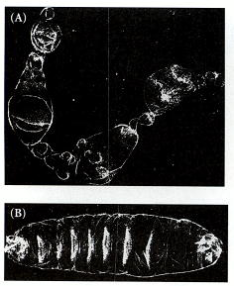
Figure 9.33. Effect of mutations affecting the distribution of the Dorsal protein. (A) Deformed larva consisting entirely of dorsal cells. Larvae like these developed from the eggs of a female homozygous for a mutation of the snake gene, one of the maternal effect genes involved in the signaling cascade that establishes a gradient of Dorsal in the embryo. (B) Larvae developed from snake mutant eggs that received injections of mRNA from wild-type eggs. These larvae have a wild-type appearance. (From Anderson and Nüsslein-Volhard 1984; photographs courtesy of C. Nüsslein-Volhard.)

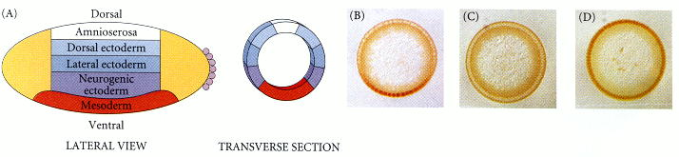
Figure 9.34. Translocation of Dorsal protein into ventral, but not lateral or dorsal, nuclei. (A) Fate map of a cross section through the Drosophila embryo. The most ventral part becomes the mesoderm; the next higher portion becomes the neurogenic (ventral) ectoderm. The lateral and epidermal ectoderm can be distinguished in the cuticle, and the dorsalmost region becomes the amnioserosa, the extraembryonic layer that surrounds the embryo. (B-D) Cross sections of embryos stained with antibody to show the presence of Dorsal protein (dark-stained area). (B) A wild-type embryo, showing Dorsal protein in the ventralmost nuclei. (C) A dorsalized mutant, showing no localization of Dorsal protein in any nucleus. (D) A ventralized mutant, in which Dorsal protein has entered the nucleus of every cell. (A from Rushlow et al. 1989; B-D from Roth et al. 1989, photographs courtesy of the authors.)

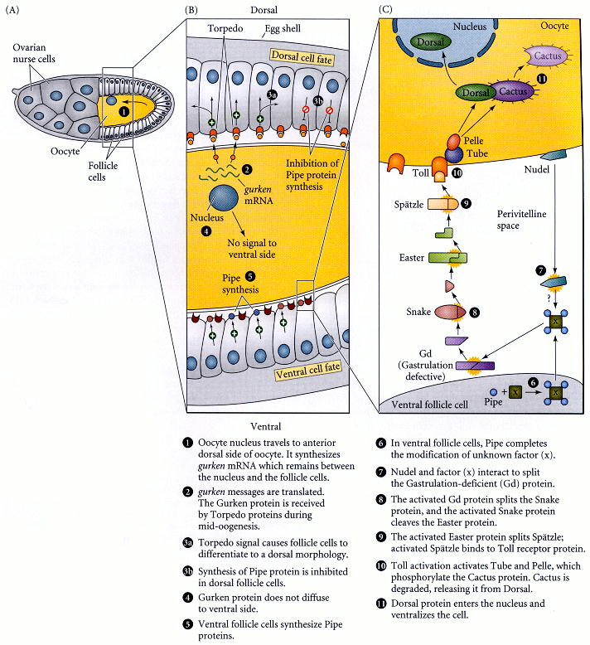
Figure 9.35. Schematic representation of the generation of dorsal-ventral polarity in Drosophila. (A) The oocyte develops in an ovarian follicle consisting of 15 nurse cells (which supply maternal proteins and messages to the developing egg) and numerous follicle cells. (B) The nucleus of the oocyte travels to what will become the dorsal side of the embryo. The gurken genes of the oocyte synthesize mRNA that becomes localized between the oocyte nucleus and the cell membrane, where it is translated into Gurken protein. The Gurken signal is received by the receptor protein made by the torpedo gene of the follicle cells. Given the short diffusibility of the signal, only the follicle cells closest to the oocyte nucleus (i.e., the dorsal follicle cells) receive this signal. The signal from the Torpedo receptor causes the follicle cells to take on a characteristic dorsal follicle morphology and (somehow) inhibit the synthesis of Pipe protein. Therefore, this protein is made only by the ventral follicle cells. (C) Pipe modifies an unknown protein (X) and allows it to be secreted from the ventral follicle cells. Nudel protein interacts with this modified factor to split the products of the gastrulation defective and snake genes to create an active enzyme that will split the zymogen form of the Easter protein into an active Easter protease. The Easter protease splits the Spätzle protein into a form that can bind to the Toll receptor (which is found throughout the embryonic cell membrane). Thus, only the ventral cells receive the Toll signal. This signal separates the Cactus protein from the Dorsal protein, allowing Dorsal to be translocated into the nuclei and ventralize the cells. (After van Eeden and St. Johnston 1999.)

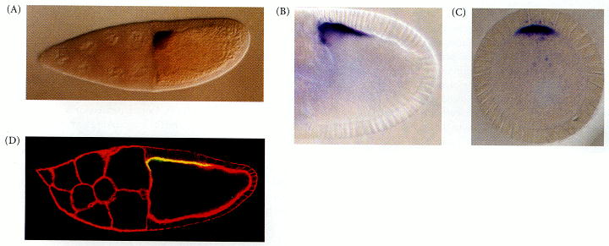
Figure 9.36. Expression of the gurken message and protein between the oocyte nucleus and the dorsal anterior cell membrane. (A) The mRNA for the Gurken protein is localized between the oocyte nucleus and the dorsal follicle cells of the ovary. (B) The Gurken protein is similarly located (shown here is a younger stage than A). (C) Cross section of the egg through the region of Gurken protein expression. (D) More mature oocyte, showing Gurken protein (yellow) across the dorsal region. The actin has been stained red, showing cell boundaries. As the oocyte grows, follicle cells migrate across the top of the oocyte, becoming exposed to Gurken. (A after Ray et al. 1996, courtesy of T. Schüpbach; B and C after Peri et al. 1999, courtesy of S. Roth; D courtesy of C. van Buskirk and T. Schüpbach.)

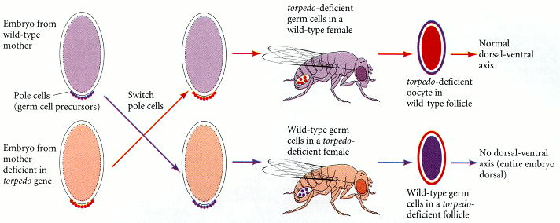
Figure 9.37. Germ line chimeras made by interchanging pole cells (germ cell precursors) between wild-type embryos and embryos from mothers homozygous for the torpedo gene. These transplants produce wild-type females whose eggs come from the mutant mothers, and torpedo-deficient females that lay wild-type eggs. The torpedo-deficient eggs produce normal embryos if they develop in the wild-type ovary, while the wild-type eggs produce ventralized embryos if they eggs develop in the mutant mother's ovary.

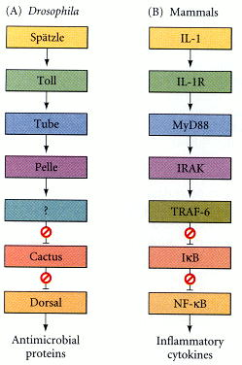
Figure 9.38. Model of a conserved pathway for regulating nuclear transport of transcription factors in Drosophila and mammals. (A) In Drosophila, the Toll protein binds the signal from the Spätzle protein and activates the kinase region of the Pelle protein. The Pelle protein phosphorylates Cactus and Dorsal, causing the two proteins to separate from each other. The Dorsal protein can then enter the nucleus and regulate the transcription of ventrally specific genes. (B) In mammalian lymphocytes, the IL-1 receptor can cause the phosphorylation of IκB (through the protein IRAK kinase). This enables the NF-κB protein to enter the nucleus and effect the transcription of several lymphocyte-specific genes involved in the inflammatory response. The particular colors indicate homologous proteins in the homologous pathway. (After Qureshi et al. 1999.)

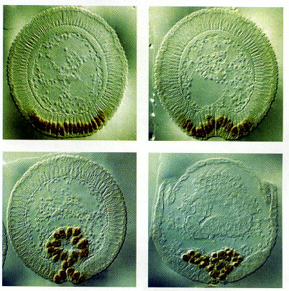
Figure 9.39. Gastrulation in Drosophila. In this cross section, the mesodermal cells at the ventral portion of the embryo buckle inward, forming a tube, which then flattens and generates the mesodermal organs. The nuclei are stained with antibody to the Twist protein. (From Leptin 1991a; photographs courtesy of M. Leptin.)

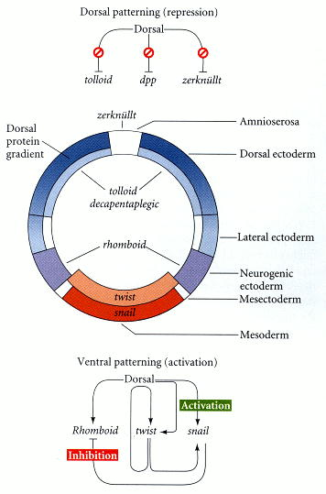
Figure 9.40. Subdivision of the dorsal-ventral axis by the gradient of Dorsal protein in the nuclei. The Dorsal protein activates the zygotic genes rhomboid,twist, and snail, depending on its nuclear concentration. The Snail protein, formed most ventrally, inhibits the transcription of the Rhomboid protein. The Dorsal protein also inhibits the expression of the tolloid,decapentaplegic, and zerknüllt genes in the ventral region. Differing concentrations of Zerknüllt protein determine the fates of the dorsal cells. (After Steward and Govind 1993.)

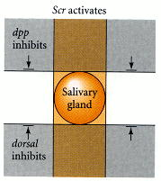
Figure 9.41. Cartesian coordinate system for the expression of genes giving rise to Drosophila salivary glands. These genes are activated by the protein product of the sex combs reduced (scr) homeotic gene in a narrow band along the anterior-posterior axis, and they are inhibited in the regions marked by decapentaplegic (dpp) and dorsal gene products along the dorsal-ventral axis. This pattern allows salivary glands to form in the midline of the embryo in the second parasegment. (After Panzer et al. 1992.)

